**Docker Desktop for Windows**

**Docker on Windows**

* Docker Desktop for Windows is the Community version of Docker for Microsoft Windows. You can download Docker Desktop for Windows from Docker Hub.

Link;

[Download from Docker Hub](https://hub.docker.com/editions/community/docker-ce-desktop-windows/)

The installation provides Docker Engine, Docker CLI client, Docker Compose, Docker Machine, and Kitematic. Containers and images created with Docker Desktop for Windows are shared between all user accounts on machines where it is installed. This is because all Windows accounts use the same VM to build and run containers.

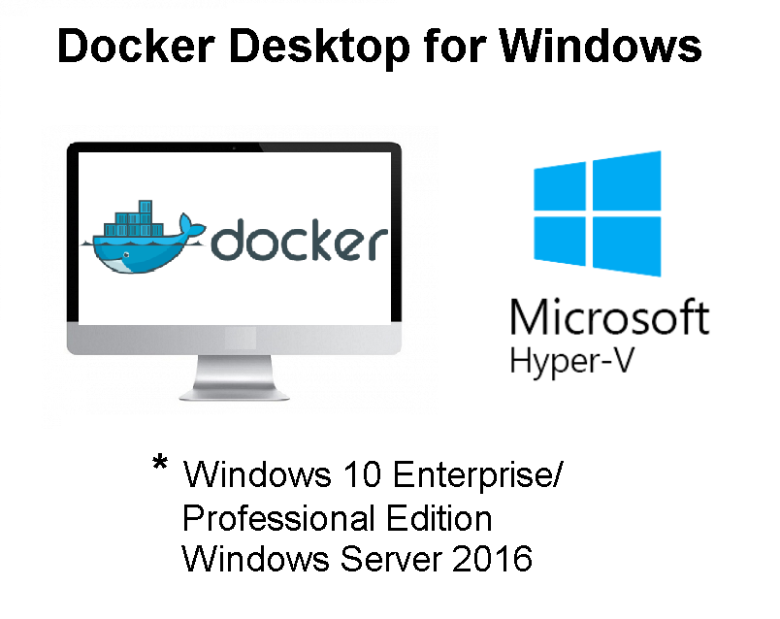

**⚠ Avoid ! :What to know before you install System Requirements:**

* Windows 10 64-bit: Pro, Enterprise, or Education (Build 15063 or later).
* Hyper-V and Containers Windows features must be enabled.
* The following hardware prerequisites are required to successfully run Client Hyper-V on Windows 10:
  + 64 bit processor with Second Level Address Translation (SLAT)
  + 4GB system RAM
  + BIOS-level hardware virtualization support must be enabled in the BIOS settings.

**Docker on Mac**

* Docker Desktop for Mac is the Community version of Docker for Mac. You can download Docker Desktop for Mac from Docker Hub.

Link;

[Download from Docker Hub](https://hub.docker.com/editions/community/docker-ce-desktop-mac/" \t "_blank)

**⚠ Avoid ! :What to know before you install** System Requirements:

* Mac hardware must be a 2010 or a newer model
* macOS must be version 10.13 or newer.
* At least 4 GB of RAM.

**💡 Tips:**

Docker Toolbox provides a way to use Docker on older Macs that do not meet minimal system requirements for Docker Desktop for Mac.

[**Download Docker Toolbox**](https://github.com/docker/toolbox/releases)